Story of Positive Impact on Group of Beneficieries
Project : KfW Soil Project

- Project Village :- Maheshmara

- Farmer’s Name and Mob. No.-
(i) Manikant Singh – 9304641886 (ii) Mirtuanjay Singh – 767546363
(iii) Ravikant Singh – 9304641887 (iv) Pratap Singh - 906810235
(v) Sunil Singh – 8404806208 (vi) Kiran Devi – 900606282
(vii) Suraj Singh – 7667413841

- Address :- At - lachhnadih, PO- Mothabari, PS- Katoria, Dist.- Banka, Pin - 813106

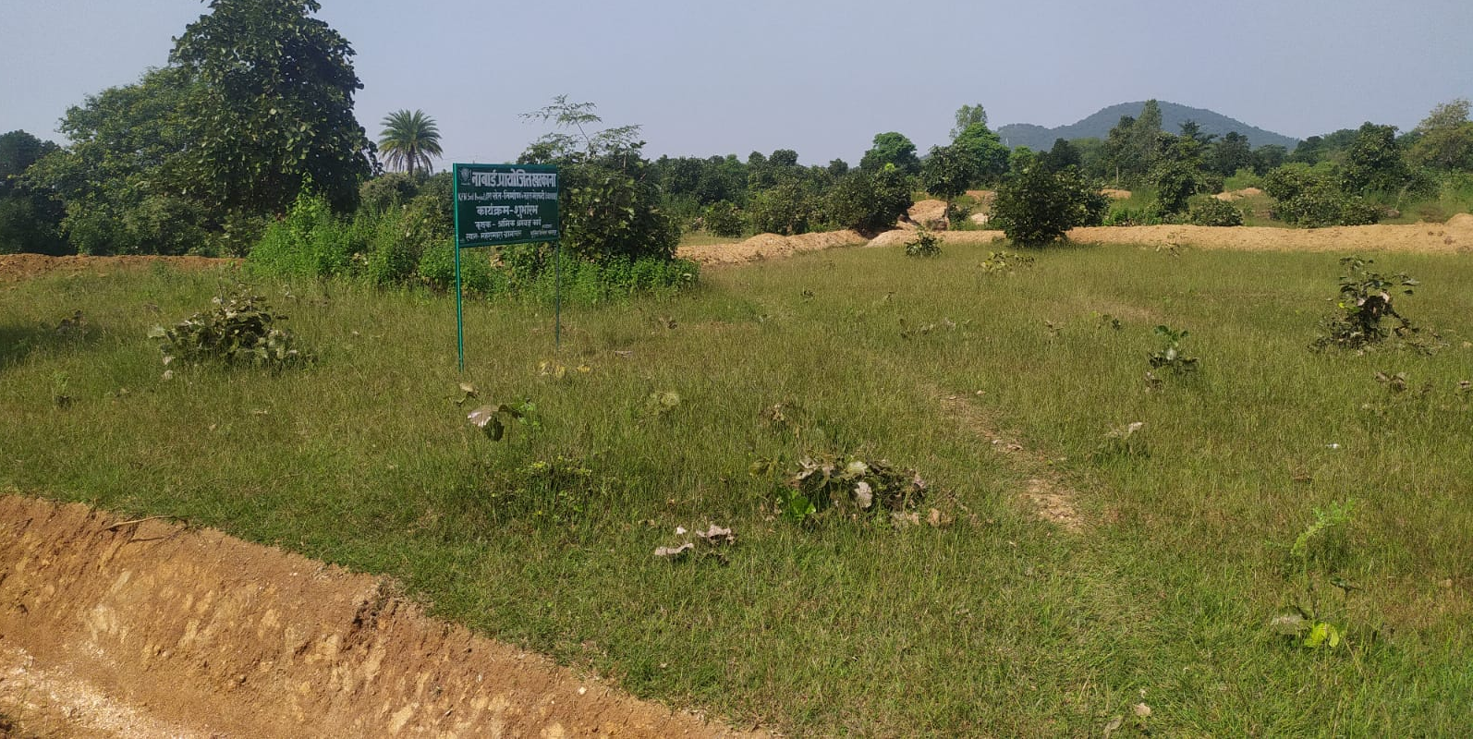
- Name of Activity:- Farm Bund

- Month of Initiation:- October 2021

- Problem Statement :-
In Maheshmara village there stood a big dunk of barren land just by the side of the village – habitation. It was a joint property. The land was in the shape of a heap, slopy, hilly, weedy and stony, some farmers tried to grow some crops but in want of irrigation if failed. People wated to convert the waste land into cultivable land.
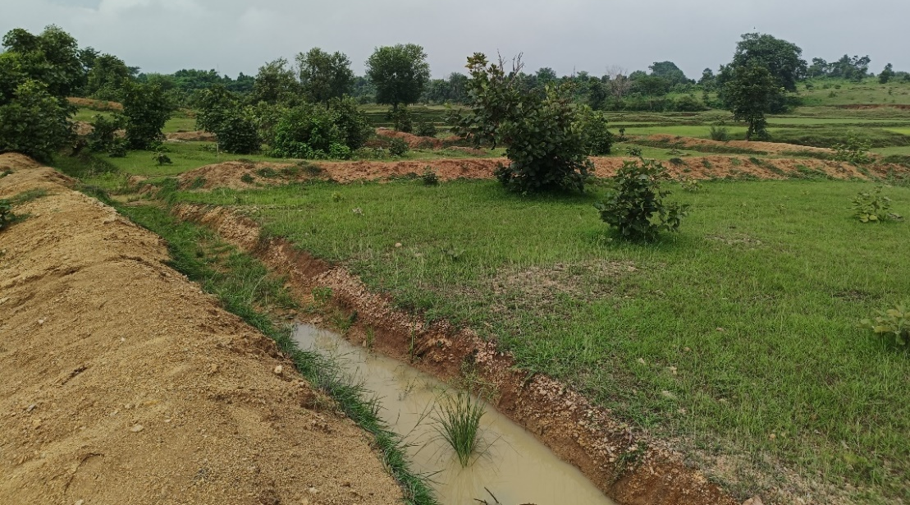
- Initiation Taken :-
When KfW Soil Project began, This plot was undertaken for farm-bund 0.25 hectares. The work begun with 20-30 labours and farmers themselves. Trenches 2' deep, 5' wide and 250'-400' length in square, uneven shapes in numbers continuously were dug. Grass was planted on bunds and the big plot of land was divided into shaped farm land, best example of rainwater harvesting and collection and conversion of waste- land to cultivatable land.

- Progress And Result :-
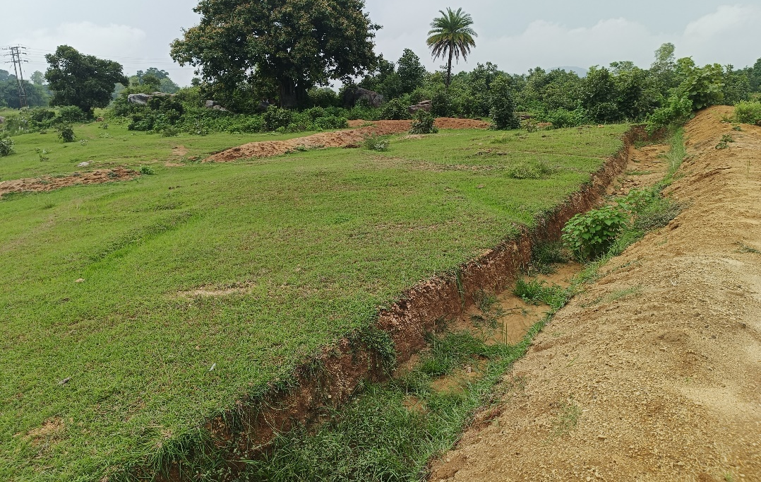
Farm land is ready. After rain water is available in all fields, Farmers have ploughed and made it plane. They have sowed kurthi and Arhar. They will sow maize, sarso and teel from the next season. They will also sow wheat, Potato and Vegetables if water could be available.

- Impact:-
The Village sight is changed with smile and hope on faces. Income has to come now.

- Inspiration :-
United efforts can bring remarkable change

